**API Chaining**

**1. Create a POST request which sets the environment variables after running**

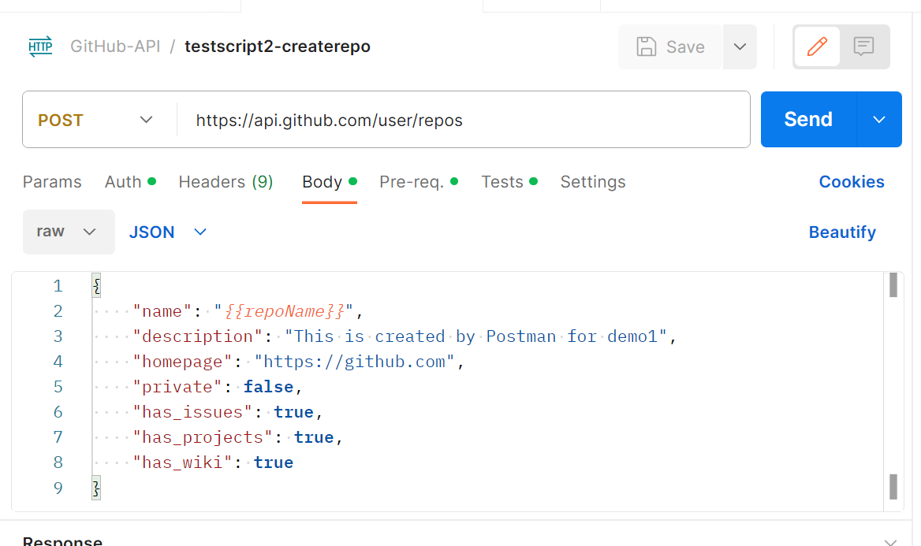

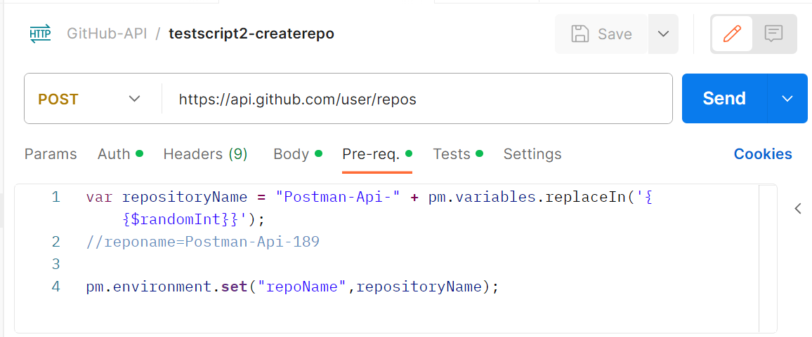

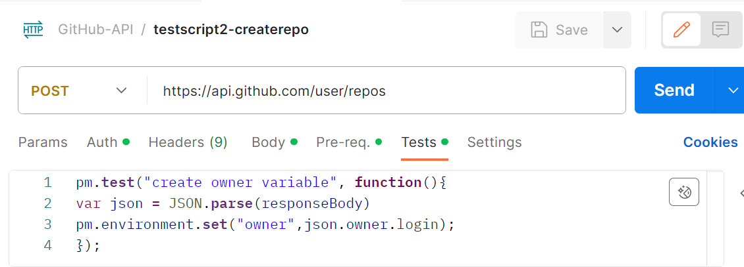

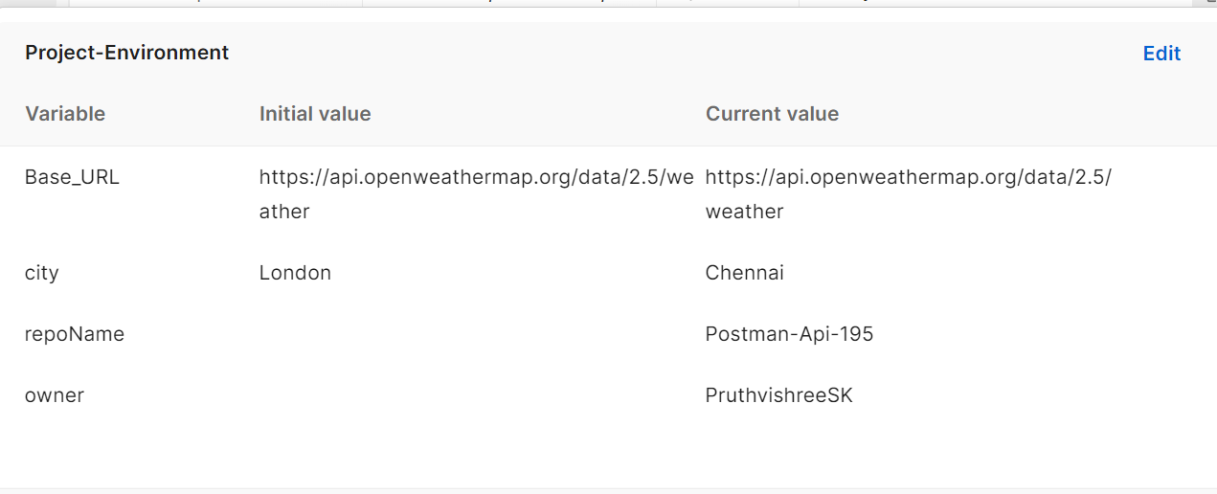

**2. Create another request which uses the variable generated in the above request**

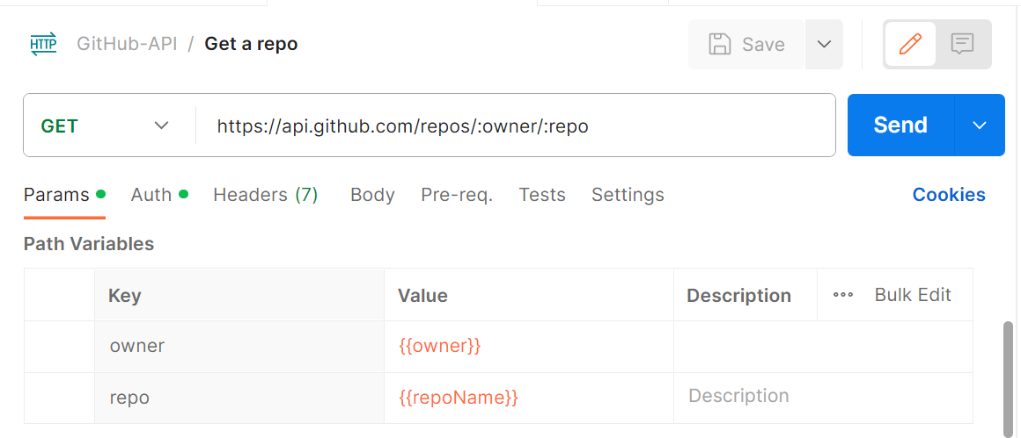

**3. Since these variables are generated from previous request, these requests can be called as chaining requests as one of it depends on another.**

**Observe the output**

